Chapter – 2
Power Generation Integration and Automation with PCC
The integration of multiple power generation sources—specifically solar energy, Energy Storage Systems (ESS), and grid power—plays a crucial role in developing a sustainable and efficient battery charging infrastructure for electric vehicles (EVs). As the demand for EV charging stations continues to rise, leveraging these diverse energy sources ensures that charging operations can meet varying energy needs while promoting environmental sustainability.
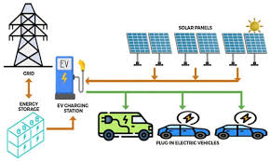
Fig 4 : Power sources integration.

2.1 Solar Energy
Solar Energy serves as a primary renewable source in this architecture, providing clean and abundant power that can be harnessed during peak sunlight hours. By incorporating solar panels into the charging infrastructure, stations can generate their own electricity, significantly reducing reliance on grid power and lowering operational costs. This approach not only minimizes carbon emissions associated with conventional energy generation but also enhances the overall efficiency of the charging process. The ability to capture solar energy for immediate use or storage in batteries ensures that EVs can be charged sustainably, aligning with global efforts to transition towards cleaner transportation solutions.

The importance of solar renewable energy for battery charging, particularly in the context of electric vehicles (EVs), cannot be overstated. As the demand for efficient and sustainable charging infrastructure rises, integrating solar energy into battery charging systems presents a viable solution to meet these needs. Solar power offers a clean, renewable source of energy that can significantly reduce reliance on fossil fuels, thereby contributing to lower greenhouse gas emissions and a smaller carbon footprint. This transition is crucial as the transportation sector increasingly shifts towards electrification.
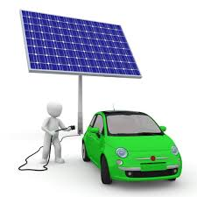
Fig 5 : Solar EV Charging

The integration of solar energy with battery charging systems not only enhances sustainability but also improves operational efficiency. By utilizing solar panels to harness energy during peak sunlight hours, charging stations can generate their own electricity, which can be stored in batteries for later use. This capability is particularly beneficial in reducing operational costs, as it allows charging stations to minimize their dependence on grid power, especially during high-demand periods when electricity prices may surge. Preliminary simulations indicate that such systems can achieve up to 90% cost efficiency through optimized resource utilization. The use of solar energy in EV charging aligns with global initiatives promoting renewable energy adoption and smart city developments. As cities strive to enhance their infrastructure and reduce environmental impacts, solar-powered charging stations become integral components of a sustainable urban ecosystem. The implementation of an IoT architecture that incorporates solar energy facilitates real-time data monitoring and predictive analytics, enabling better management of power demand and enhancing battery performance.

The importance of Maximum Power Point Tracking (MPPT) in solar energy systems, particularly for applications such as electric vehicle (EV) charging, is paramount for optimizing energy efficiency and performance. MPPT is a technology that enables solar inverters to continuously adjust their operating point to extract the maximum possible power from solar panels, regardless of varying environmental conditions such as sunlight intensity and temperature. This capability is crucial because solar panels do not operate at peak efficiency under all conditions; therefore, MPPT ensures that the system can adapt in real-time to maximize energy harvest.

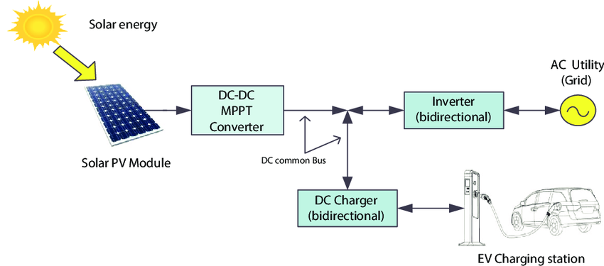
Fig 6 : Solar with MPPT Unit

The integration of MPPT significantly enhances the overall effectiveness of solar power utilization. By optimizing the energy extracted from solar panels, MPPT allows for greater power availability for charging operations. For instance, during peak sunlight hours, an MPPT-enabled system can increase the output voltage and current supplied to the battery charging station, thereby improving charging speeds and reducing wait times for users. This is particularly important as the demand for fast and efficient charging solutions continues to rise alongside the increasing adoption of electric vehicles.

2.2 Energy Storage Systems (ESS)
Energy Storage Systems (ESS) complement solar energy by providing a means to store excess power generated during sunny periods. This stored energy can be utilized during times when solar generation is insufficient, such as at night or during cloudy weather. ESS enhances the reliability of the charging infrastructure by ensuring a consistent power supply, thereby addressing one of the significant challenges associated with renewable energy—intermittency. By prioritizing the use of stored solar energy before drawing from the grid, charging stations can optimize their energy usage and further reduce costs.

Energy Storage Systems (ESS) play a critical role in the infrastructure of electric vehicle (EV) charging by enhancing the efficiency and reliability of power supply. As the demand for EVs continues to rise, integrating ESS with renewable energy sources, such as solar power, and grid electricity becomes essential for creating a sustainable charging ecosystem. ESS allows for the storage of excess energy generated during peak sunlight hours, which can then be utilized during periods of low solar generation or high demand. This capability ensures that charging stations can maintain a consistent and reliable power supply, addressing one of the primary challenges associated with renewable energy—intermittency.
The incorporation of ESS into EV charging infrastructure not only maximizes the utilization of renewable energy but also contributes to significant cost savings. By storing solar energy for later use, charging stations can reduce their reliance on grid power, particularly during peak pricing periods. This strategic use of stored energy not only lowers operational costs but also enhances the overall efficiency of the charging process. Furthermore, ESS can provide ancillary services to the grid, such as load balancing and frequency regulation, further supporting grid stability and resilience.
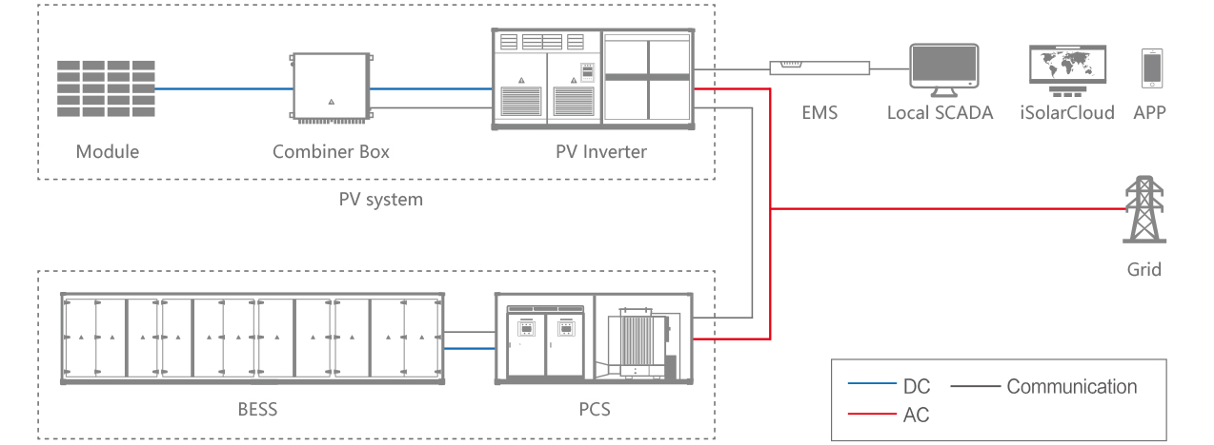
Fig 7 : Battery Energy Storage System
In the proposed IoT architecture for battery charging management, ESS is integrated at the Point of Common Coupling (PCC), allowing for seamless interaction between solar power generation, stored energy, and grid electricity. This integration is facilitated by real-time data monitoring and predictive analytics, enabling operators to optimize energy usage based on current availability and demand forecasts. By prioritizing solar energy first, followed by stored energy from ESS, and utilizing grid power as a backup, this architecture ensures that charging stations operate at maximum efficiency.

Grid Power
Grid Power serves as a backup source in this integrated system, ensuring that charging stations can maintain operations even when solar generation and stored energy are inadequate to meet demand. The strategic use of grid power allows for flexibility in managing energy loads, particularly during peak demand periods when EV usage may surge. By integrating grid power into the architecture, the system can adapt to fluctuations in energy requirements while still prioritizing renewable sources whenever possible.

The integration of grid power into electric vehicle (EV) charging infrastructure, particularly in conjunction with solar energy and Energy Storage Systems (ESS), is essential for creating a reliable and efficient charging ecosystem. Grid power serves as a crucial backup source, ensuring that charging stations can maintain operations even when solar generation and stored energy are insufficient to meet demand. This capability is particularly important during peak demand periods, when EV usage may surge, creating fluctuations in energy requirements.
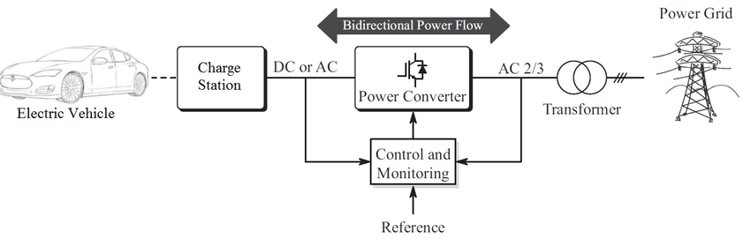
Fig 8 : Grid EV Charging
By strategically incorporating grid power into the architecture, the system can adapt to varying energy loads while prioritizing renewable sources whenever possible. This flexibility allows charging stations to optimize their energy management by drawing from solar power first, utilizing stored energy from ESS next, and resorting to grid electricity only when necessary. Such an approach not only enhances the reliability of the charging infrastructure but also contributes to overall operational efficiency.
The integration of grid power also facilitates load balancing and frequency regulation within the energy network. During times of high demand, charging stations can draw additional power from the grid to ensure that they can meet user needs without interruption. Conversely, during low-demand periods or when excess solar energy is generated, these stations can feed surplus energy back into the grid or store it in ESS for later use. This bi-directional flow of energy enhances the resilience of both the charging infrastructure and the broader electrical grid.

2.4 Point of Common Coupling (PCC).
The proposed IoT architecture facilitates real-time monitoring and management of these three energy sources at the Point of Common Coupling (PCC). This centralized approach enables operators to track energy production and consumption dynamically, optimizing charging schedules based on current availability and demand. By employing predictive analytics, the system can forecast energy needs and adjust operations accordingly, ensuring that resources are utilized efficiently.

The proposed IoT architecture for battery charging management effectively integrates three energy sources—solar power, Energy Storage Systems (ESS), and grid power—at the Point of Common Coupling (PCC). This centralized approach enables dynamic monitoring and management of energy production and consumption, optimizing charging schedules based on current availability and demand. The system is designed to automate operations based on the availability of solar energy: when solar generation is sufficient, the ESS charges from solar power while the grid remains off. This prioritization of renewable energy not only enhances sustainability but also reduces operational costs.
When solar energy is unavailable, the ESS activates to provide power to the load, ensuring that charging operations continue seamlessly. If the ESS reaches a state where its charge exceeds 80%, it can export surplus energy back to the grid through a bi-directional circuit. This feature not only maximizes the utilization of renewable resources but also allows for energy trading, potentially generating revenue for charging station operators. Conversely, when the ESS charge drops below 20%, grid power is activated to ensure that there is always sufficient energy available for charging operations.

In scenarios where there is no load on the system, the ESS can recharge from grid power, ensuring that it remains ready to supply energy when needed. This intelligent management of energy sources at the PCC allows for a flexible and responsive charging infrastructure that can adapt to fluctuations in demand while prioritizing renewable energy use.

The implementation of predictive analytics within this architecture further enhances its capabilities. By forecasting energy needs based on historical data and real-time monitoring, the system can adjust operations proactively, ensuring optimal resource utilization. This integration of advanced analytics not only improves efficiency but also supports better decision-making regarding energy management.

The integration of solar power, ESS, and grid electricity within a well-designed IoT architecture at the PCC creates a robust and efficient EV charging infrastructure. This system not only meets current energy demands but also promotes sustainability by maximizing renewable energy use and minimizing reliance on fossil fuels. The automated management of these three energy sources ensures that charging stations can operate reliably and efficiently, ultimately contributing to a greener transportation ecosystem.

